**DevOps CAPSTONE PROJECT**

Deploy entire website into the cloud infrastructure (AWS) with proper scaling.

Member’s:

20A91A04J2

20A91A04O4

20A91A0345

Set up an AWS account: The first step is to create an AWS account and sign in to the AWS Management Console.

Create an EC2 instance: Launch an EC2 instance with an appropriate operating system (Linux or Windows) and an instance type that meets the website's resource requirements. Choose a VPC, subnet, and security group for the instance.

Install NodeJS and MongoDB: After launching the instance, install NodeJS and MongoDB on the instance.

Configure MongoDB: Configure MongoDB by creating a user and setting up the database.

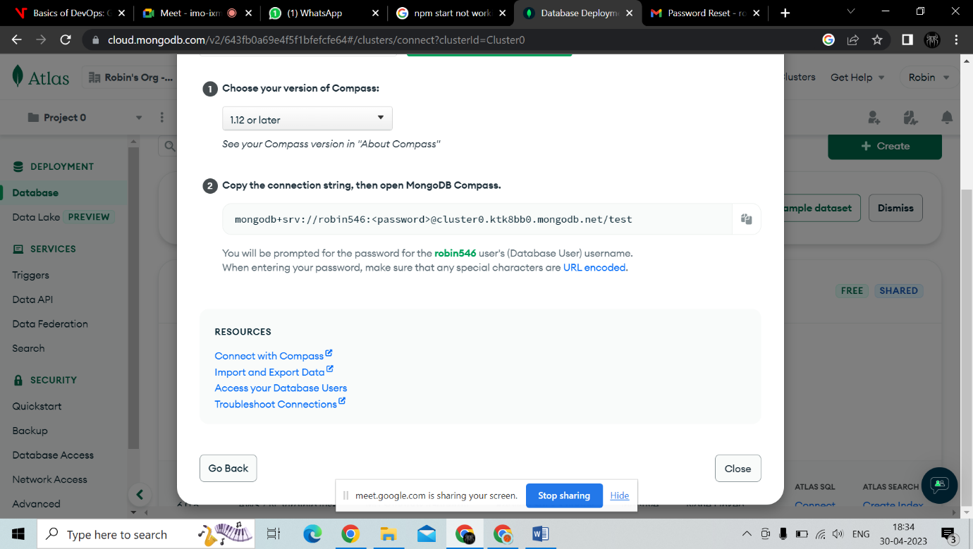

Clone the code repository: Clone the code repository to the EC2 instance.

Install dependencies: Install all the necessary dependencies required by the project.

Build and start the project: Build and start the project by running the appropriate commands.

Configure Nginx: Install and configure Nginx as a reverse proxy server to handle incoming requests.

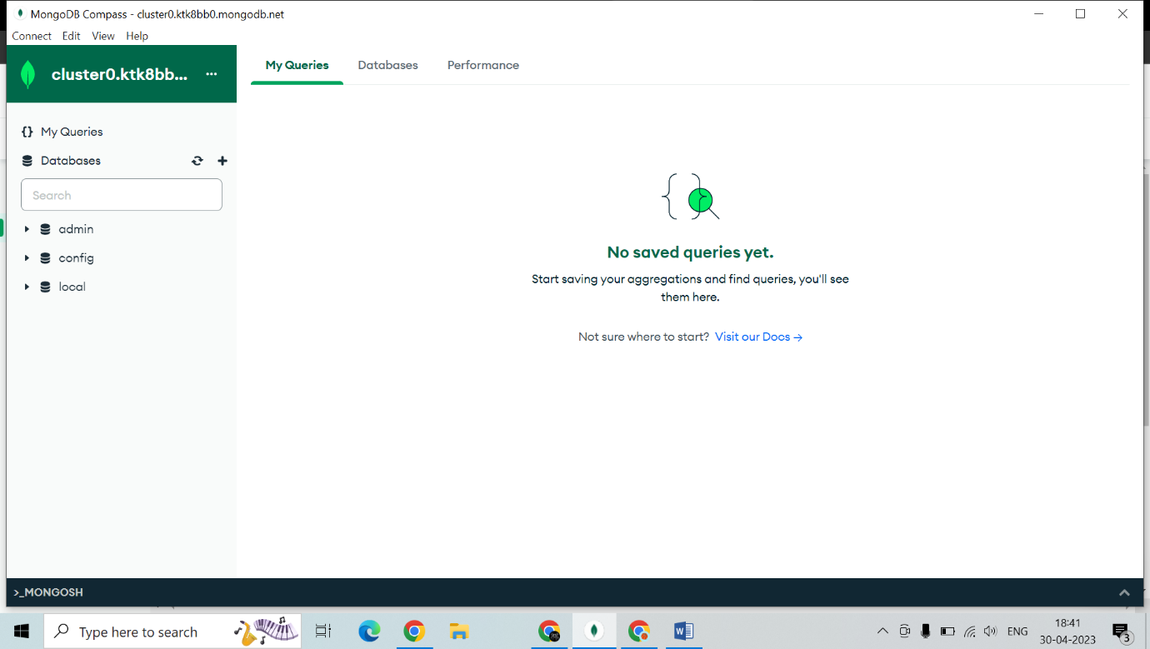Create an S3 bucket: Create an S3 bucket to store the images uploaded by users.

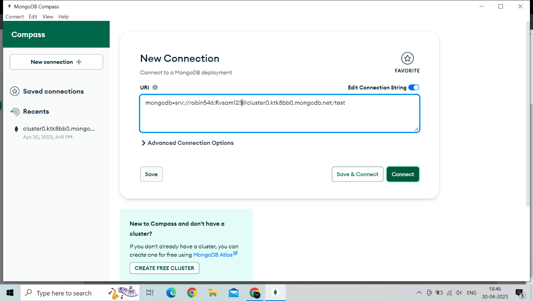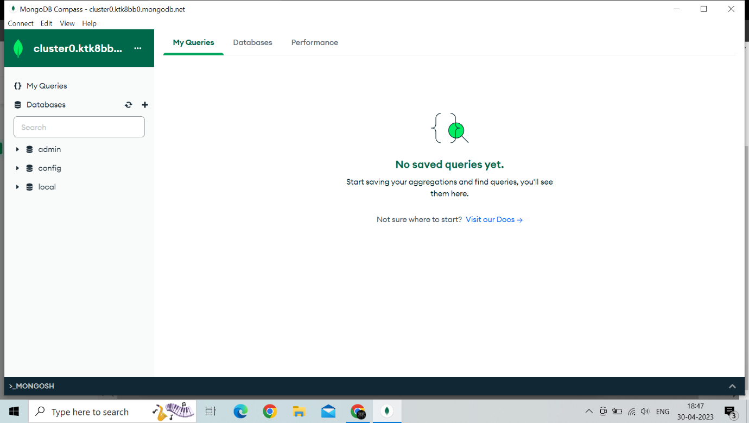

MongoDB stores data in flexible, JSON-like documents, meaning fields can vary from document to document and data structure can be changed over time

The document model maps to the objects in your application code, making data easy to work with

Ad hoc queries, indexing, and real time aggregation provide powerful ways to access and analyze your data

MongoDB is a distributed database at its core, so high availability, horizontal scaling, and geographic distribution are built in and easy to use

MongoDB is free to use. Versions released prior to October 16, 2018 are published under the AGPL. All versions released after October 16, 2018, including patch fixes for prior versions, are published under the Server Side Public License (SSPL) v1.

MongoDB Atlas is a multi-cloud database service by the same people that build MongoDB. Atlas simplifies deploying and managing your databases while offering the versatility you need to build resilient and performant global applications on the cloud providers of your choice.

MongoDB Atlas is a cloud service by MongoDB. It is built for developers who'd rather spend time building apps than managing databases. This service is available on AWS, Azure, and GCP.

It is the worldwide cloud database service for modern applications that give best-in-class automation and proven practices guarantee availability, scalability, and compliance with the foremost demanding data security and privacy standards. We can use MongoDB's robust ecosystem of drivers, integrations, and tools to create faster and spend less time managing our database.

Enable SSL: Enable SSL to ensure that the website is secure. 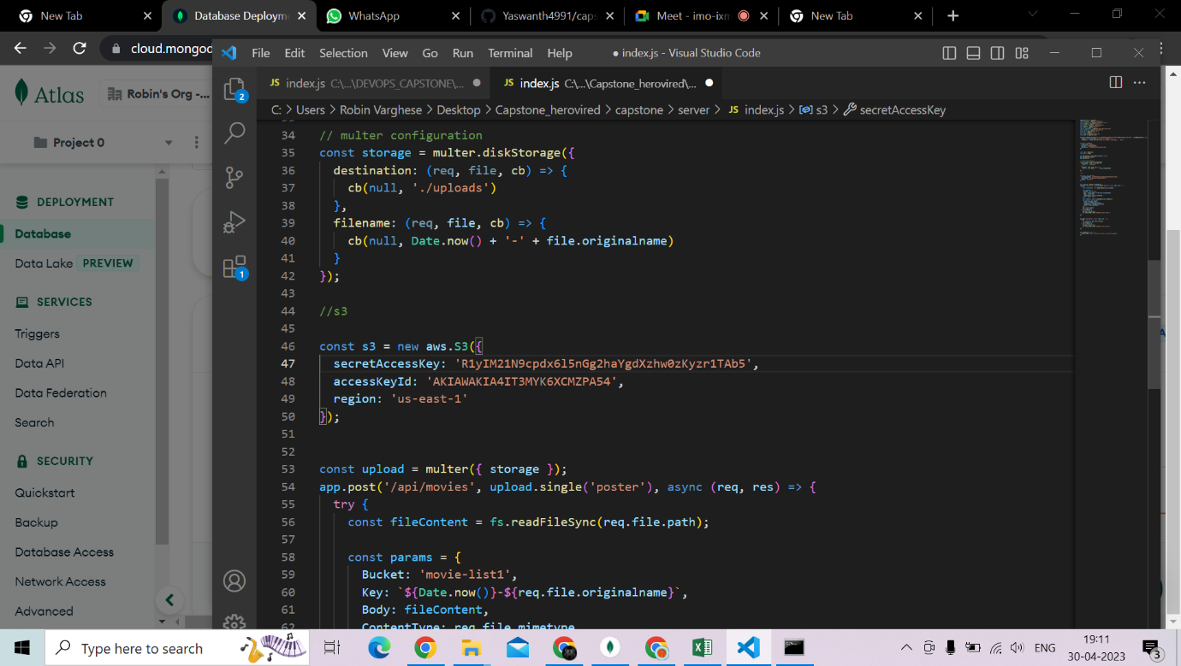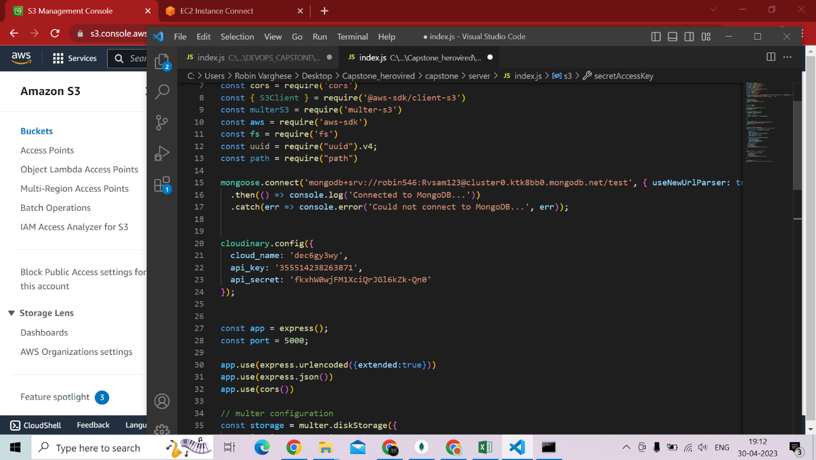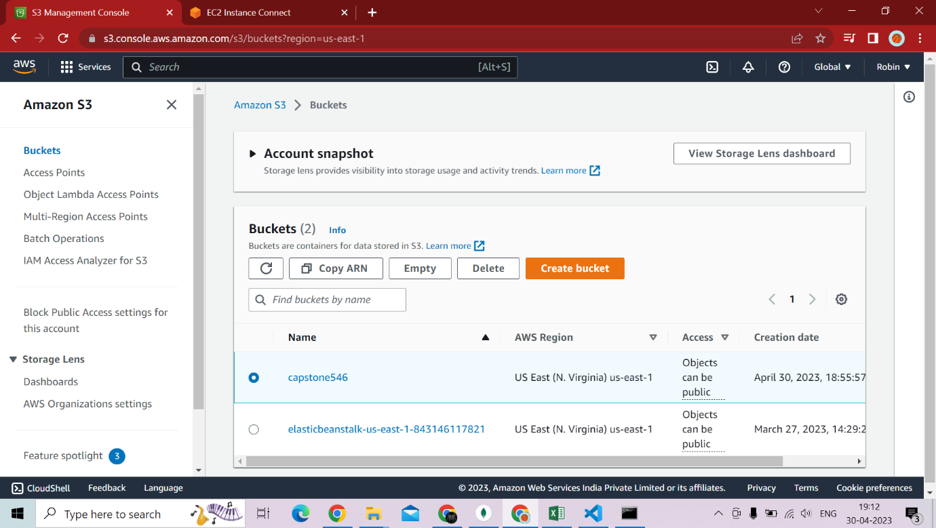

Configure S3 for file storage: Configure the NodeJS application to use the S3 bucket for storing the images.

Set up auto-scaling: Set up auto-scaling to automatically adjust the number of instances based on traffic.

Set up load balancing: Set up load balancing to distribute traffic across the instances.

Set up monitoring and alerts: Set up monitoring and alerts to ensure that the website is running smoothly and to receive notifications if there are any issues.

Test and deploy: Test the website thoroughly and deploy it to the AWS infrastructure.

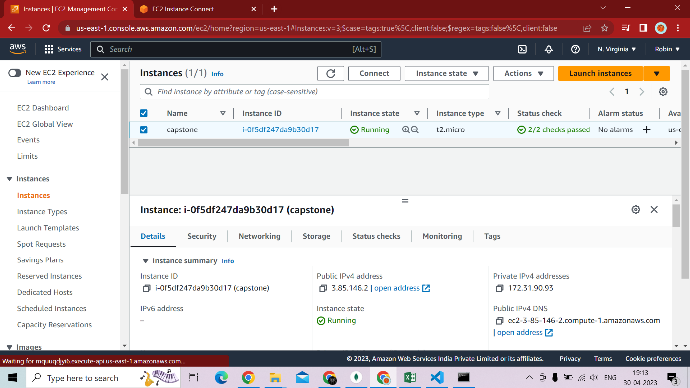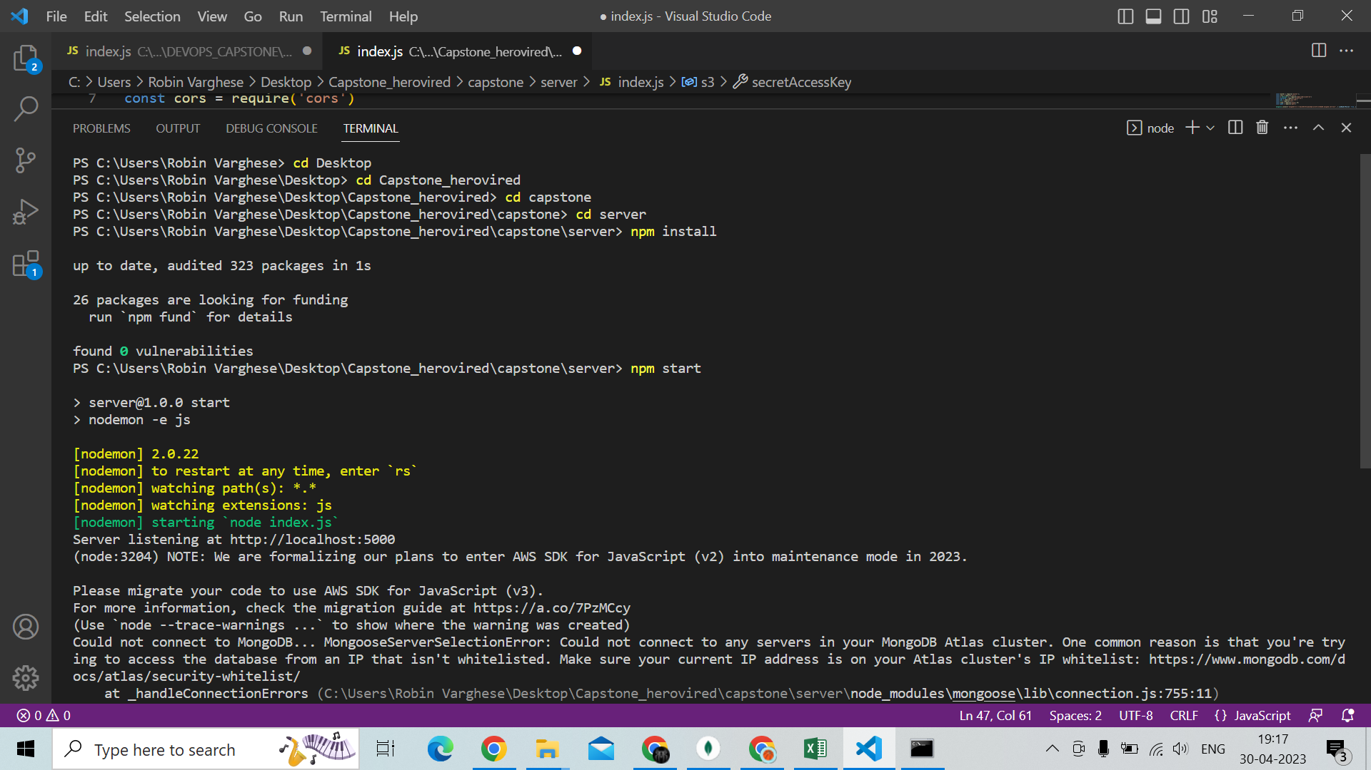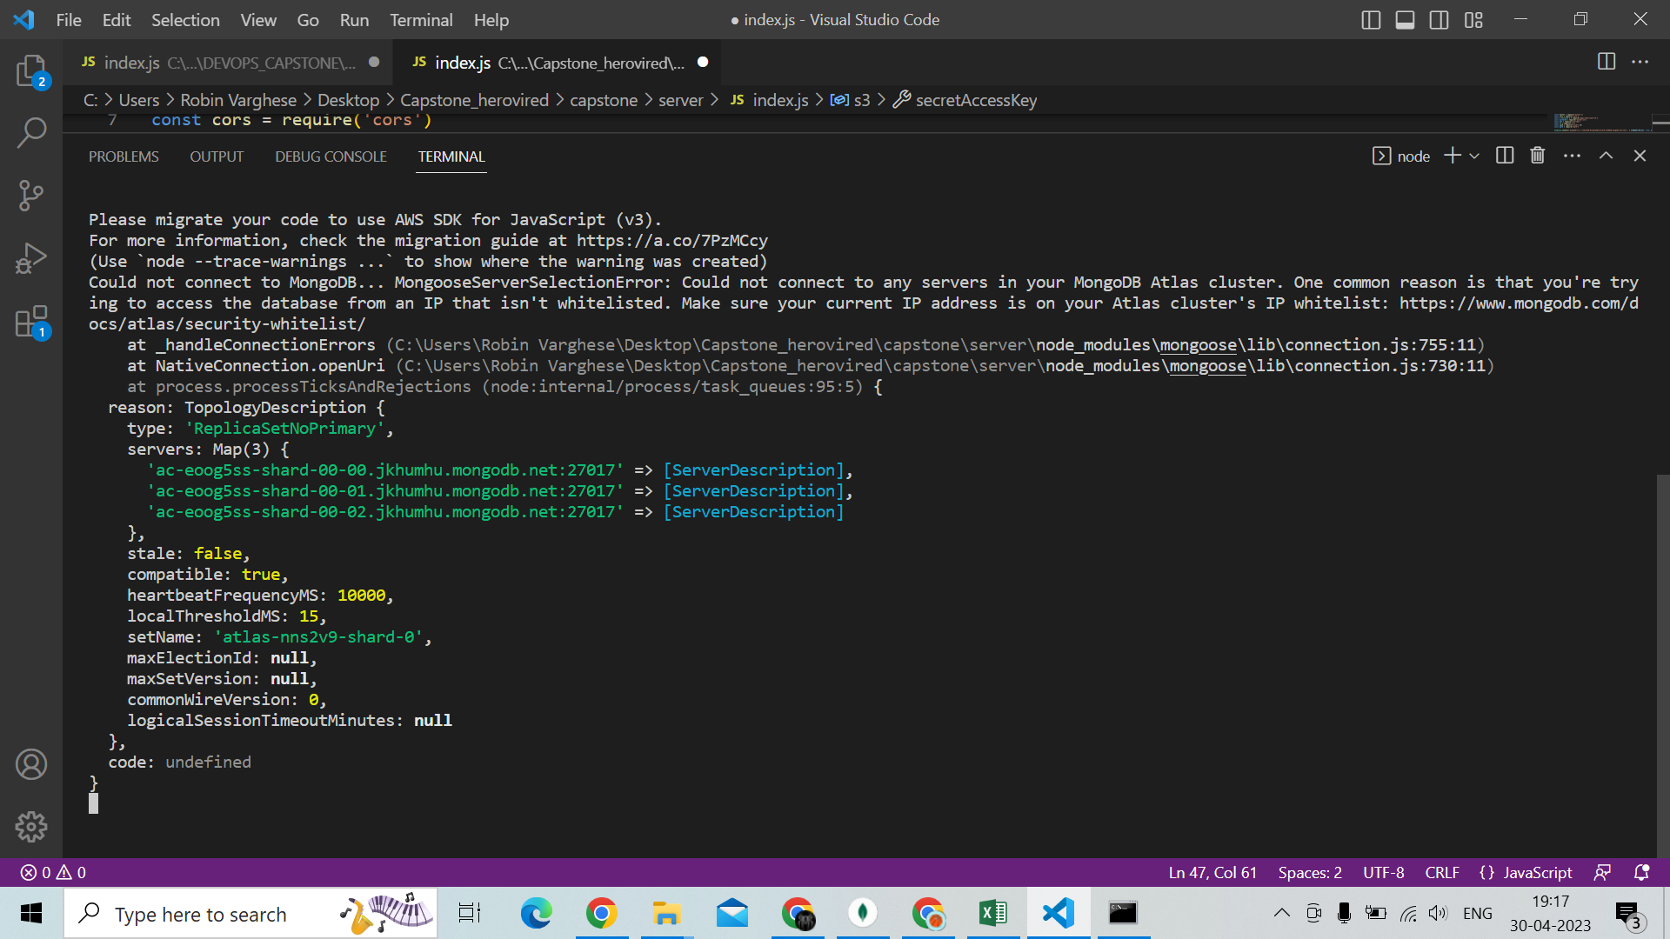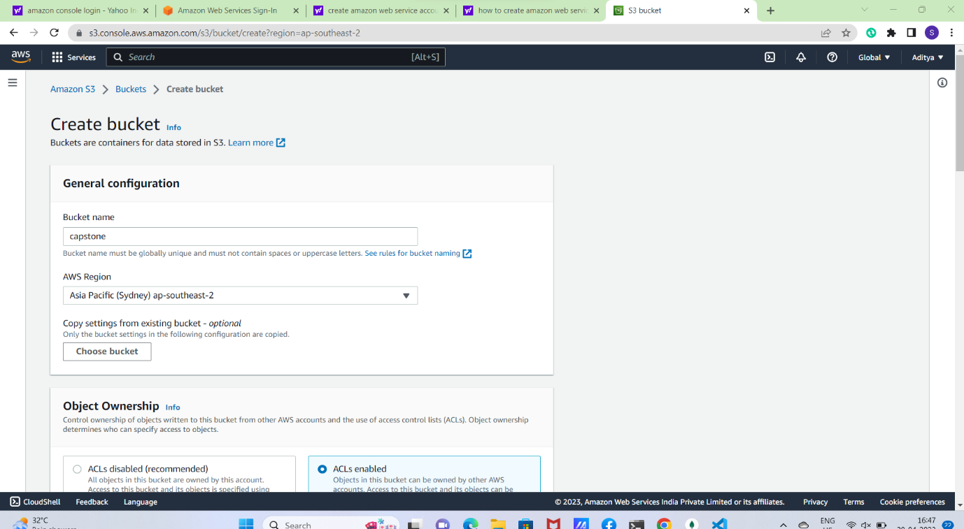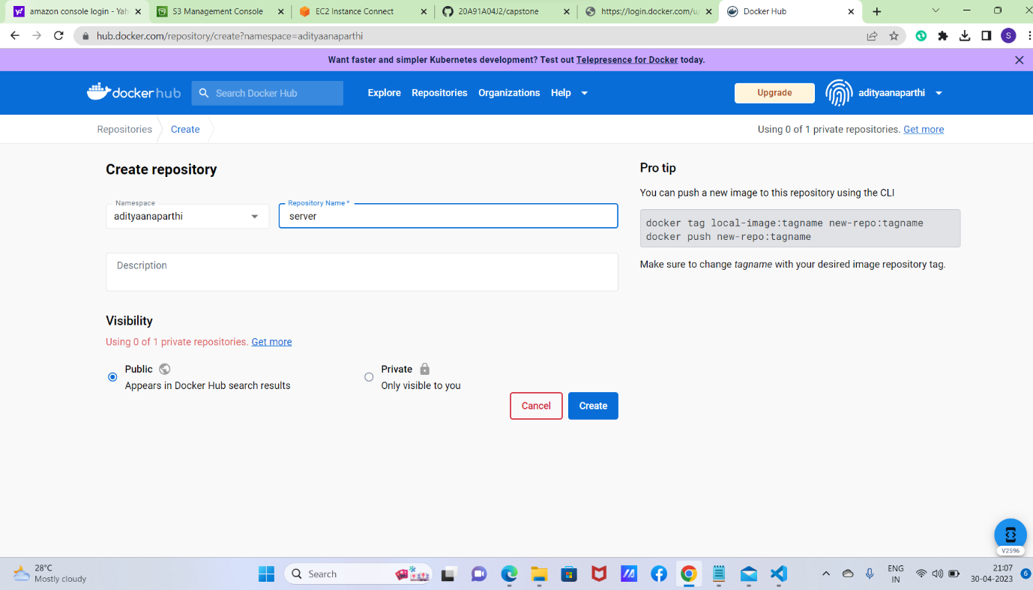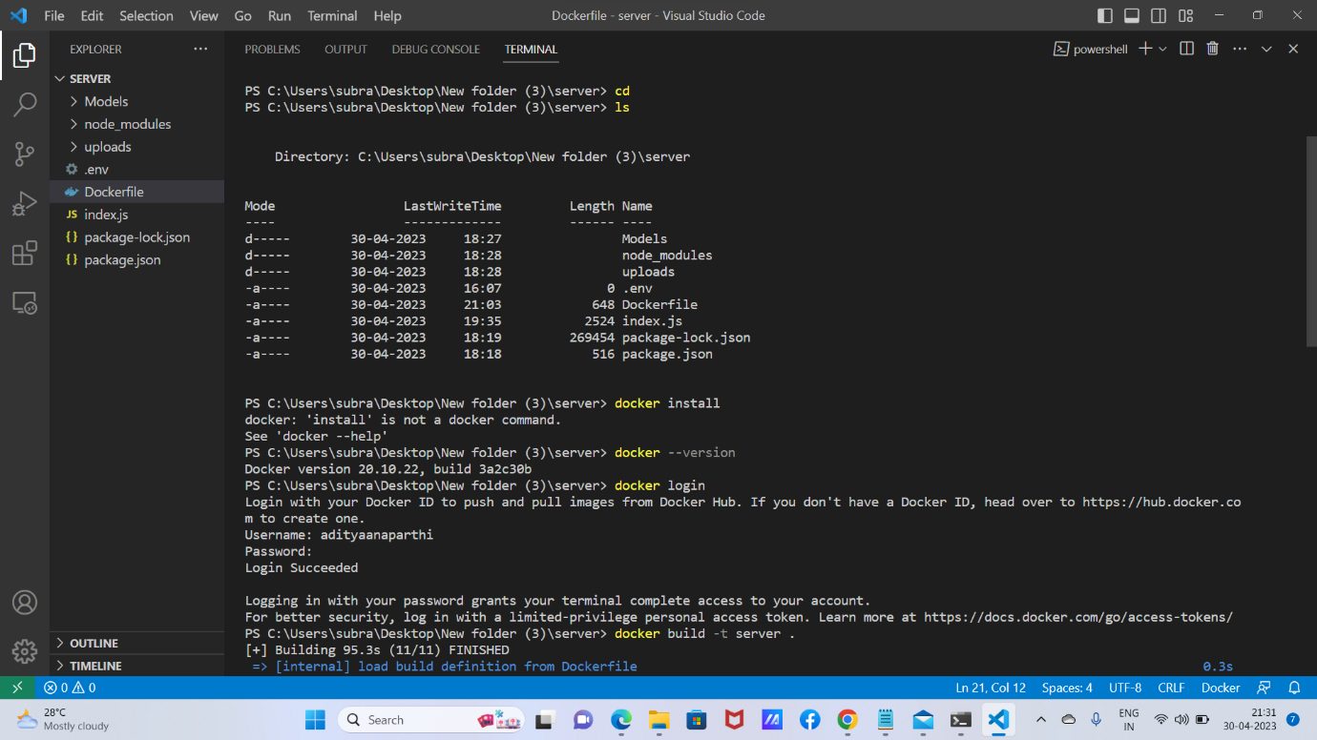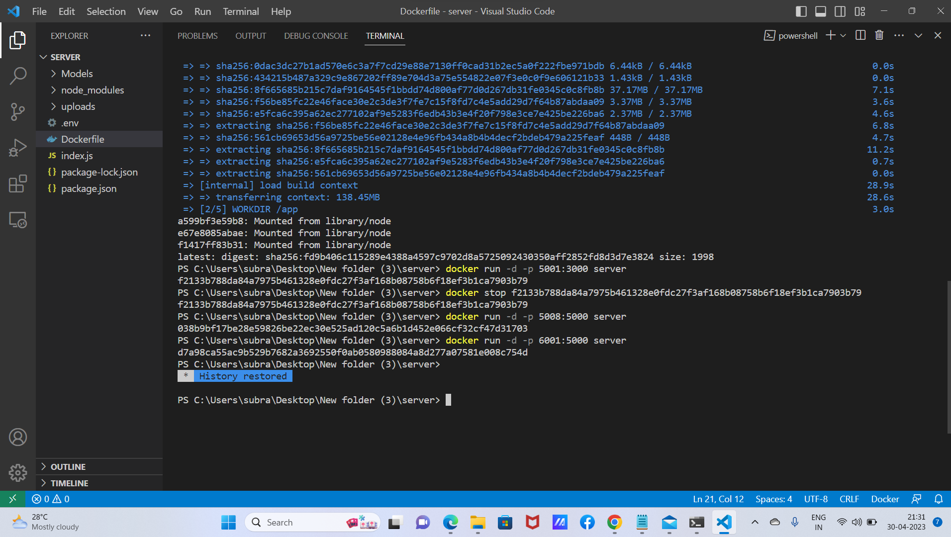

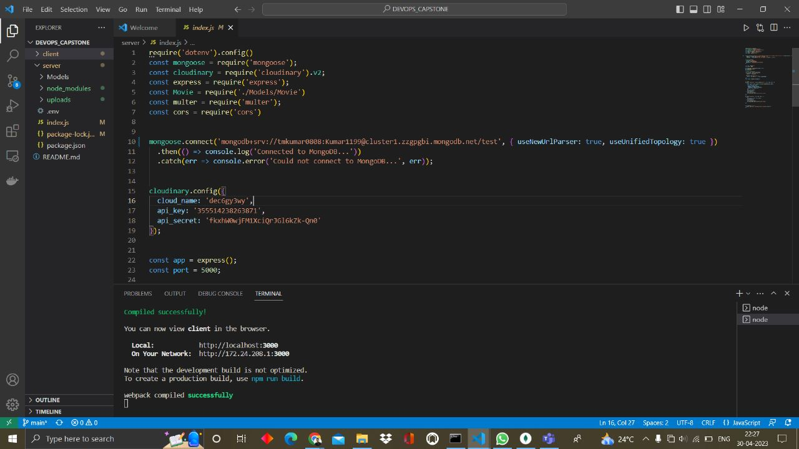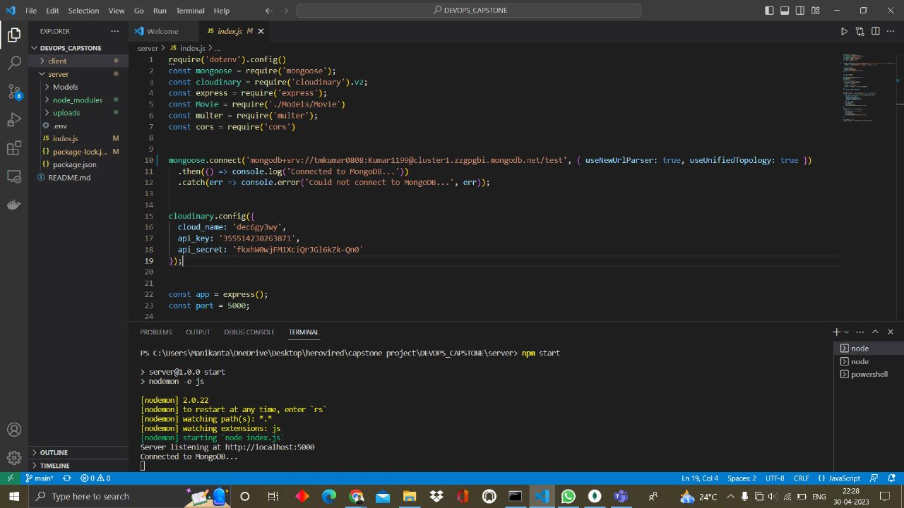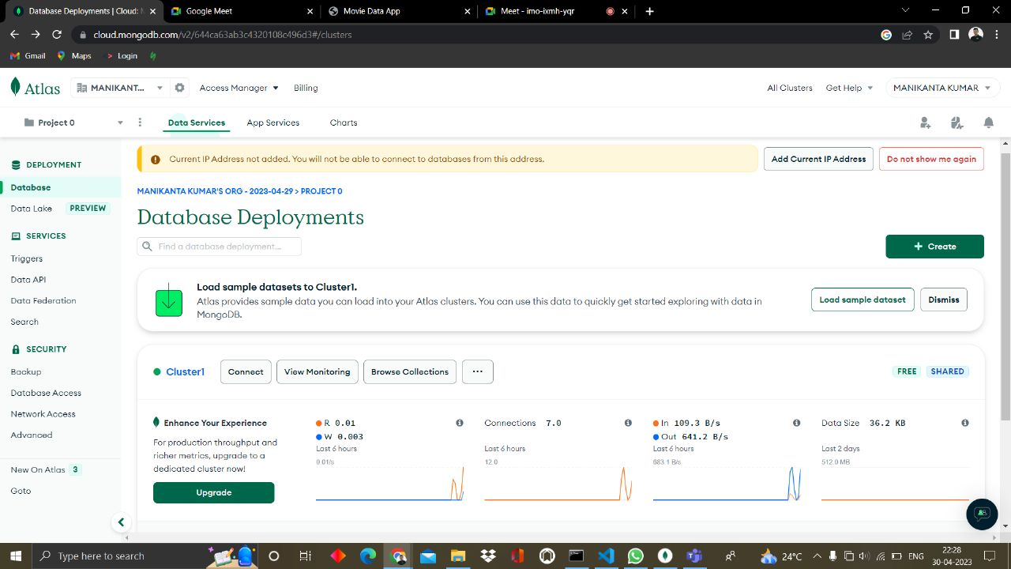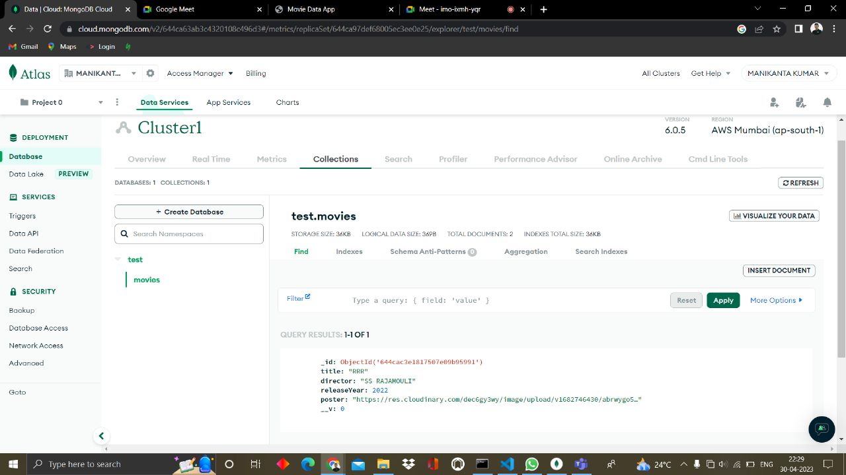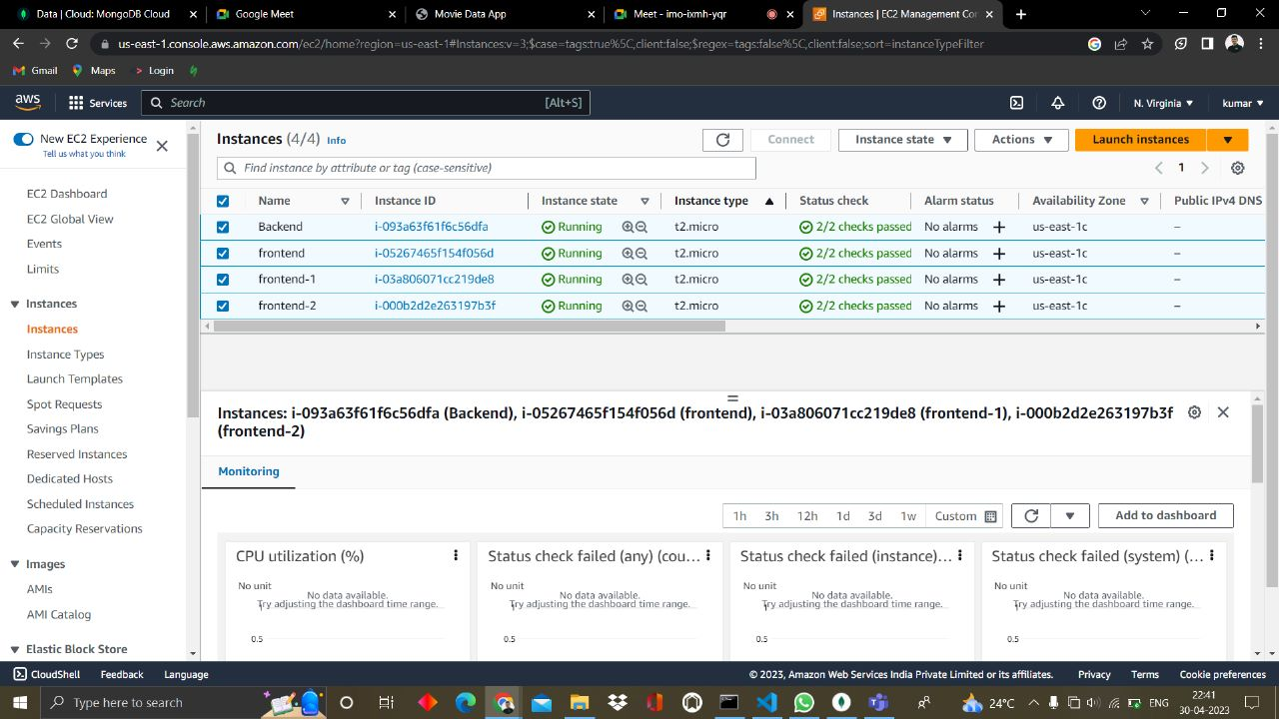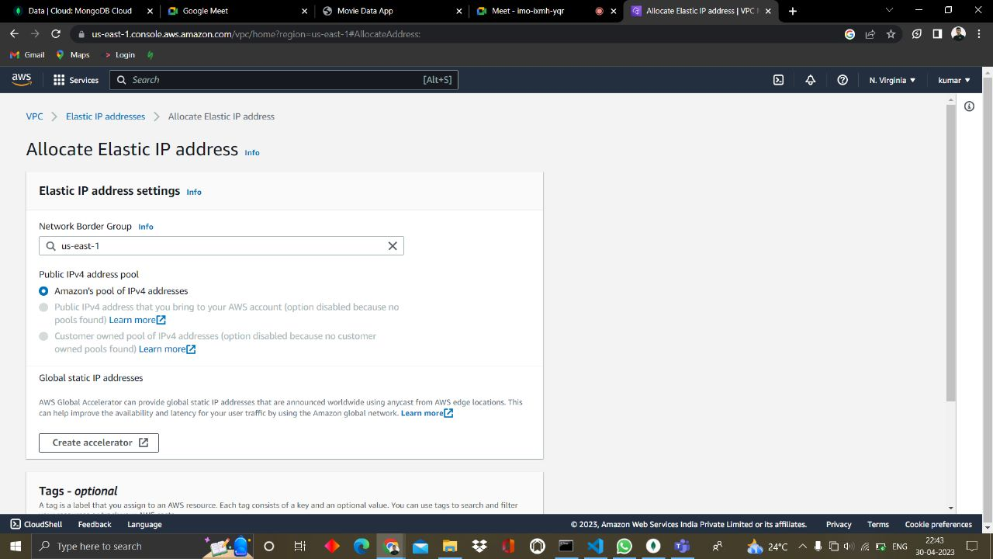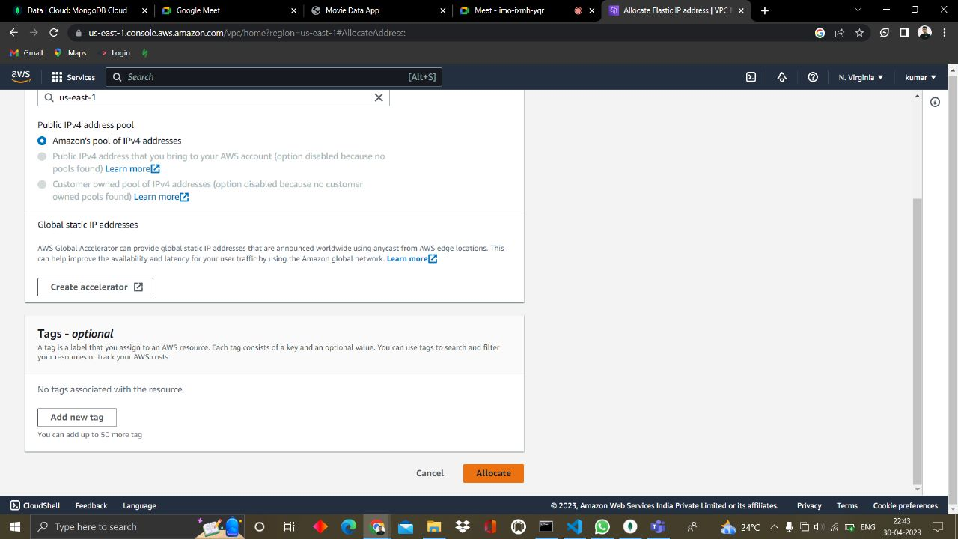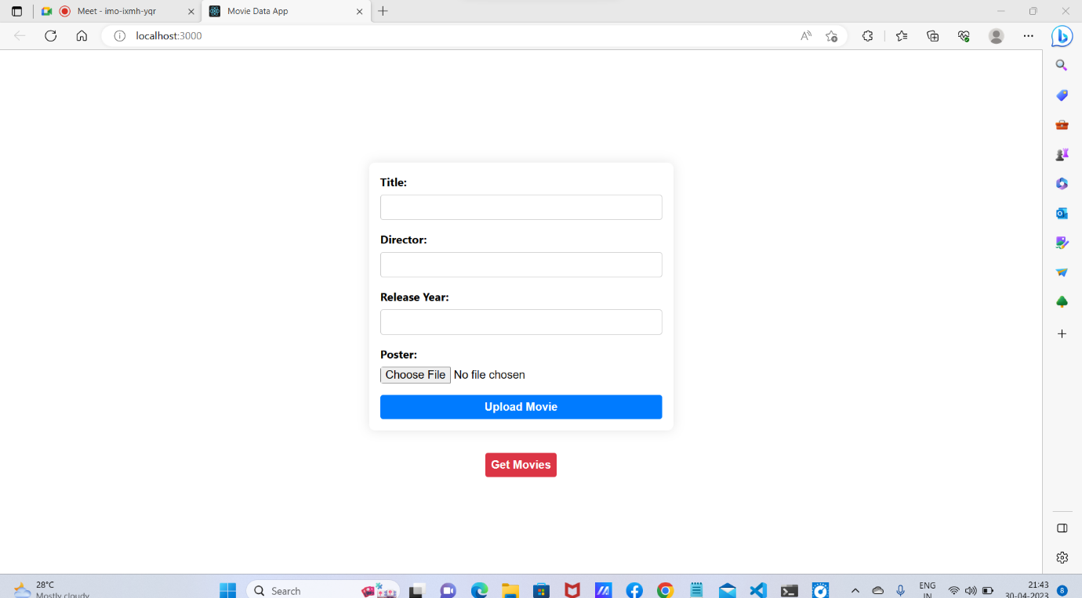

Use AWS S3 for storing images: Replace local storage with AWS S3 storage for storing images. Use the multer-s3 library to upload and retrieve images from S3.

Replace local database with Atlas MongoDB cloud infrastructure: Use Atlas MongoDB to host the database in the cloud. Migrate the data from the local MongoDB to Atlas MongoDB.

Deploy Backend in EC2 instance and attach Elastic IP: Use Docker to containerize the backend application and deploy it on an EC2 instance. Use Elastic IP to assign a static IP address to the instance.

Modify Frontend code to fetch data from Backend: Update the frontend code to fetch data from the backend API instead of local storage.

Deploy Frontend using Docker into EC2 instance: Containerize the frontend application and deploy it on an EC2 instance using Docker. Ensure that the frontend can communicate with the backend API running on a separate EC2 instance.

Create Load balancer and attach to scale website traffic: Use an Elastic Load Balancer (ELB) to distribute traffic to multiple EC2 instances running the backend application. Configure Auto Scaling to automatically add or remove EC2 instances based on traffic demand.

Use DNS to point to IP: Use Amazon Route 53 to register a domain name and point it to the Elastic IP address assigned to the load balancer.

Create AWS deployment diagram and suggest methods to improve it: Create a diagram that outlines the different components of the infrastructure, their interactions, and how they are deployed. Suggest methods to improve the architecture, such as using Amazon CloudFront to cache static content, using Amazon RDS to manage the database, and using AWS Lambda to handle serverless functions.

Host docker images into AWS ECR/Docker hub: Store the Docker images in either AWS Elastic Container Registry (ECR) or Docker Hub for easy deployment and management.

By following these steps, the "Movie listing" website can be successfully deployed in the cloud infrastructure (AWS) with proper scaling. 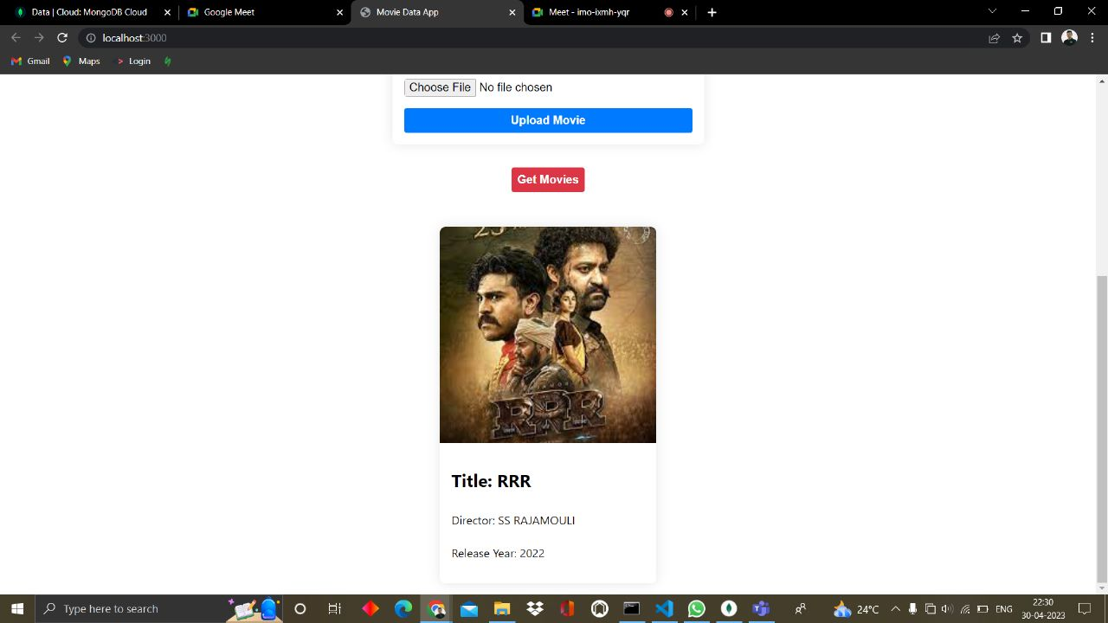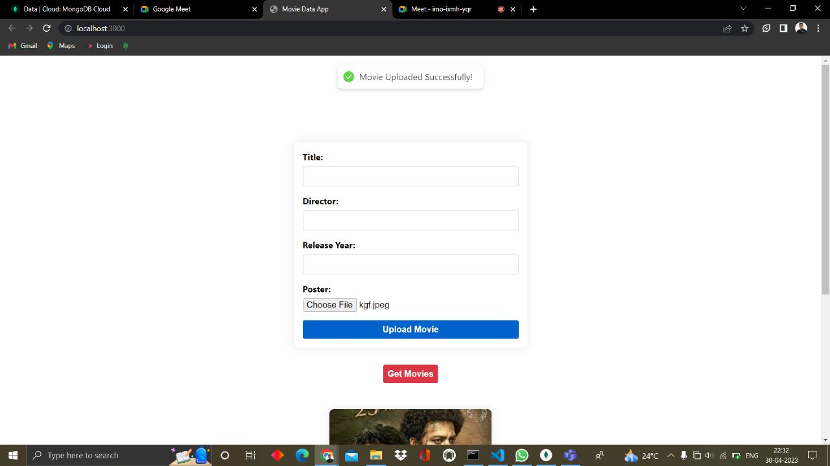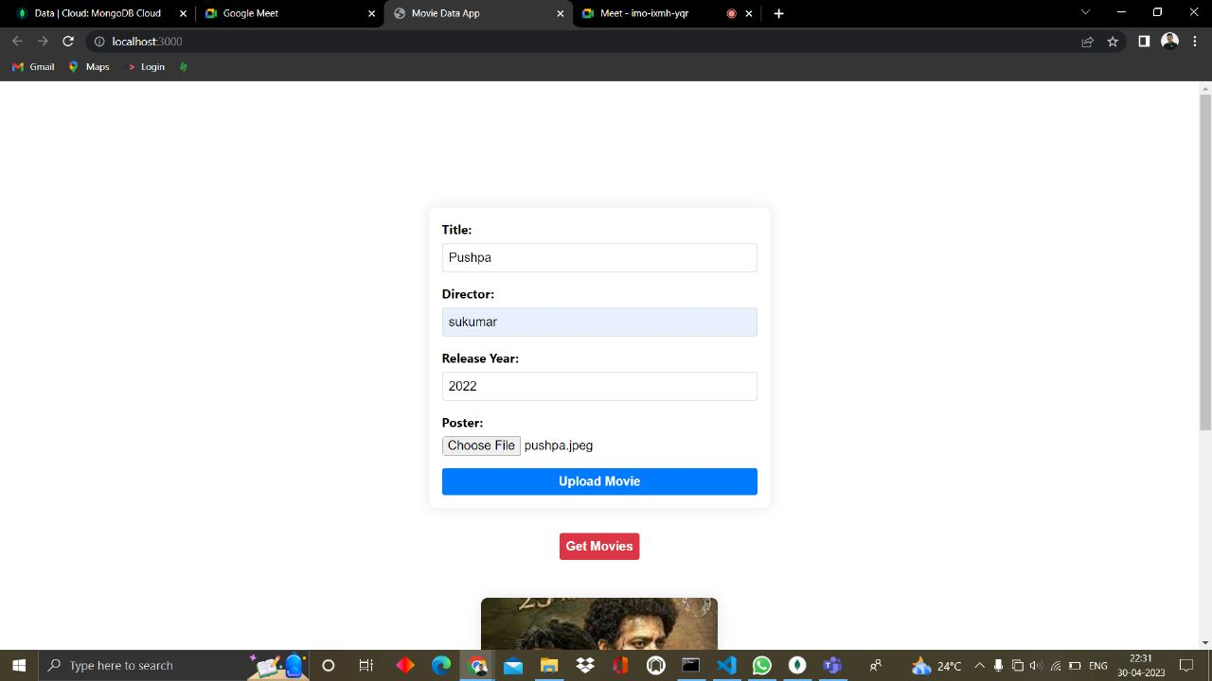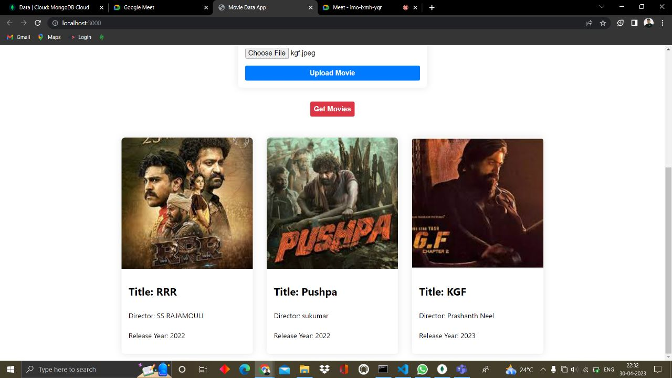

Deploying diagram:

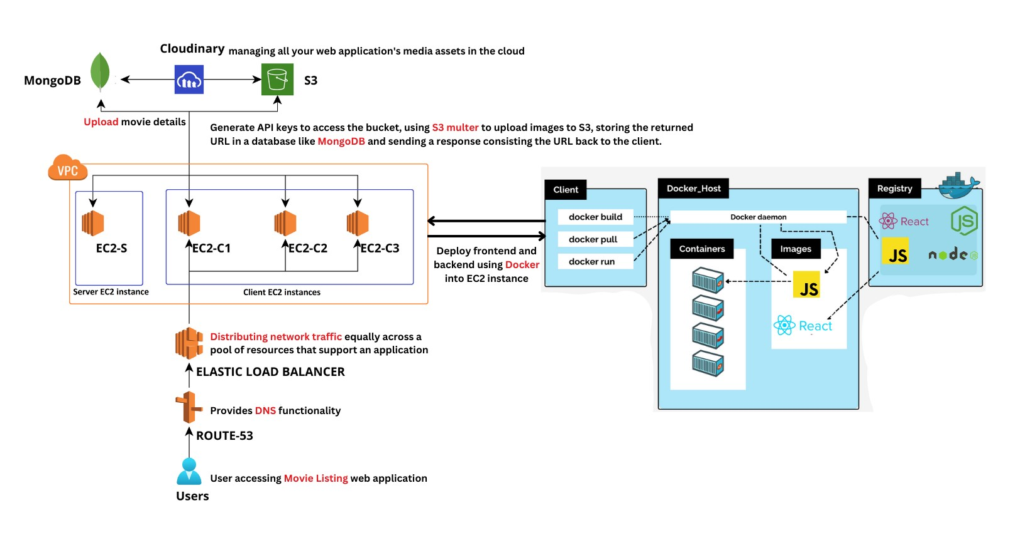

Group contributon:

**Connecting the Server with Atlas MongoDB and** **Robin Varghese**

**Creating IAM user and Configuring S3-bucket**

**Deploying server on EC2 using Docker and Deploying Containerization of the code using Dockerfile.. Aditya Anaparthi**

**Containerization and Configuring the Application Code with S3-multer and Creation a target group and Load BalancerPreparing Project Documentation. Manikanta Kumar**

**Conclusion:**

Given Capstone project involves ReactJs, NodeJS, MongoDB, S3-multer and AWS. Our

frontend application allows us to upload movies along with posters, Title, Director name and

Movie released year and also, we have 2 features i.e., upload movies and get movies. We

used S3 to store Posters. We deployed frontend and backend using Docker. User can get

movies and the details of movies